DepthAI camera modules and connectors

Introduction
The DepthAI camera modules and connectors are a deciding factor in which product makes sense for you. Whether you are developing your own product or deciding which available board to purchase, which cameras that device contains offers tradeoff in flexibility, capabilities, quality, and cost. Before going through options, I will explain a bit more on these modules. To get straight to the options, go to the end of the doc.
Unfortunately, these cameras (and sometimes their connectors) can be the most difficult hardware in a design to procure. The DepthAI team is working hard with Arducam to make more camera options widely available in any quantity (coming soon!). The FFC designs are being modified to match Arducam’s 22 pin interface (which also matches the RPi 22 pin interface) and so are several camera modules. These changes will make life easier for makers and greatly reduce this problem of buying compatible CCMs.
Background and Sourcing
Compact Camera Modules (CCMs) as shown in the picture below, are board mounting camera modules that contain a sensor. Making each camera (or really the sensor inside) interface with the Myriad X through the SoM is the value that DepthAI provides you. By using the camera modules/sensors which they have already developed the software stack for, you save yourself 90% of the time involved in making an embedded computer vision device.
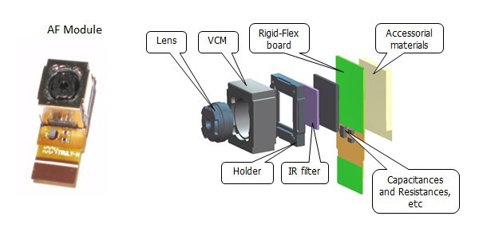
Figure 1: CCM diagram. Each component of the CCM is made by someone other than the camera manufacturer and thus multiple companies often have identical modules. The important part is what sensor is inside the camera, more on that later.
These CCMs are most used in extremely high-volume consumer electronics and thus can be hard to get in low volume. Many cameras only have one compatible board connector. Others have a couple, but I will do my best to go through each available camera type, it’s uses and associated connectors at the end of this document.
Thus, for prototyping purposes, some camera modules have been stocked for low quantity sales by Luxonis. If you plan on moving your product into mid-volume production make sure you have a plan for sourcing. If you reach out to the Luxonis team they will be happy to help you source however they can. Luckily for the open-source community, Luxonis is working with a company to bring CCMs to the consumer market permanently and improve upon the proprietary mess that is the camera industry. While the below may look like a lot of manufacturers, many of these will be unlikely to take a call from you without an order of 10,000 or more.

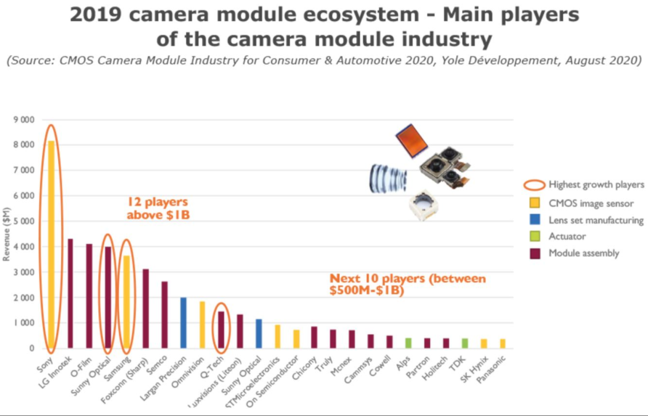

DepthAI compatible cameras:
Camera | Ref. Designs | Sensor | Connector/Source | Specs | FOV
Sunny Optical AN01V32 | BW1098s  BW1092  BG0250TG | OV9282 | ACON BBR43-24KB533 (can help source) | Monochrome 1MP  MIPI 4 Lane | 85°
Sunny Optical A12N02A | BW1098s  BW1096 OAK-1  BG0249  BW1092 | IMX378 | 24-5804-030-000-829 (digi-key) | RGB 12MP, 4k @ 60 Hz  1080p @ 240 Hz
Arducam 9281* | - | OV9281/82 | 15/22 pin FFC Arducam/RPi | Monochrome 1MP Global Shutter M12  1280 x 800@120 fps | 75°H
Arducam OV9281 NoIR* | - | OV9281/82 | 15/22 pin FFC Arducam/RPi | Monochrome 1MP Global Shutter NoIR M12 | 130° D  110° H  90° V
Arducam OV9281 FE* | - | OV9281/82 | 15/22 pin FFC Arducam/RPi | Monochrome 1MP Fisheye | 155° H  166° D
Arducam | - | OV5642 | Arducam/RPi | Color 5MP | -
Arducam | - | IMX214 | Arducam/RPi | Color 13MP | -
Arducam* | - | IMX283 | Arducam/RPi | Color 20MP | -
Arducam 477 CS* | - | IMX477 | 15/22 pin FFC Arducam/RPi | Color High Quality IR-CUT  12.3MP  CS Lens | 65° H
Arducam 12MP IMX477 Mini* | - | IMX477 | 15/22 pin FFC Arducam/RPi | Color 4056(H) x 3040(V) 12.3MP  M12 | -
* Coming soon

COMING SOON: BW2099 Baseboard, will retain compatibility with all of the above camera modules

Hyperfocal distance – the effective ‘range’ of your autofocusing camera can be important. For the IMX378, that is a bit over 10 feet.

Design Modularity:
Using the right connectors and baseboard design, creating a modular setup of the above cameras is quite reasonable. If you are looking to create your own modular design, the BW2098POE and BW1096 Oak-1 are great references for what that may look like. Or if you need a quick solution, try out one of those already tested designs!

Myriad X BW2099 SoM:

The BW2099 SoM can be made to handle up to 6 cameras. The limit is about 500 (700?) megapixels/second. So, could handle 8x 2MP cameras at 30FPS.
16 Configurable MIPI Lanes can connect to 8 HD resolution RGB cameras directly to the Movidius Myriad X. The stereo depth accelerator can simultaneously process 6 camera inputs (3 stereo pairs) each running 720p resolution at 60 Hz framerate.

Myriad X BW1099/EMB
The BW1099 and BW1099EMB are extremely similar except for NOR flash space for onboard programs. Both can handle up to 8 configurable MIPI lanes which gives capabilities for 2 stereo cameras and 1 RGB camera, or 4 stereo cameras.
** All SoMs come with 512MB LPDDR4, inquire for 1GB option

Additional notes:

Stereo modes:

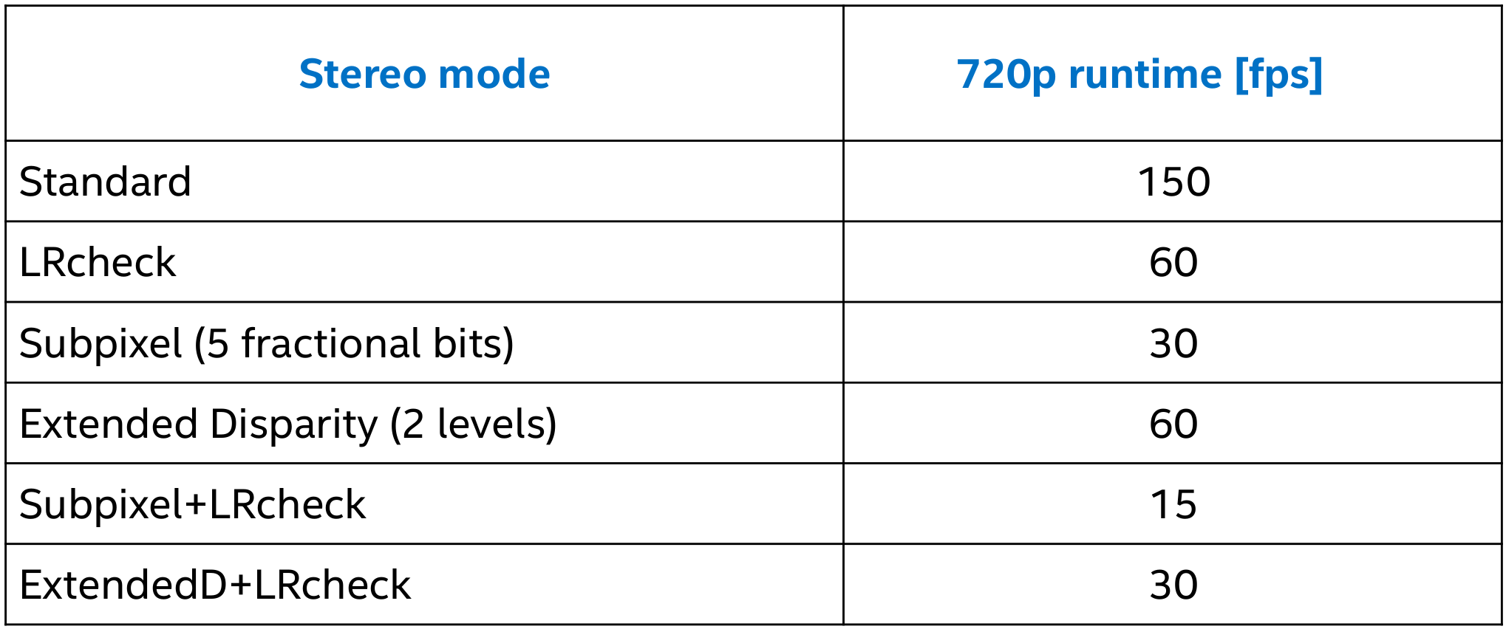

Left-Right check: used to remove incorrectly calculated disparity pixels due to occlusions at object borders (Left and Right camera views are slightly different).
1. computes disparity by matching in R->L direction
2. computes disparity by matching in L->R direction
3. combines results from 1 and 2, running on Shave: each pixel d = disparity_LR(x,y) is compared with disparity_RL(x-d,y). If the difference is above a threshold, the pixel at (x,y) in final disparity map is invalidated.

Subpixel: improves the precision, especially useful for long range measurements.
Beside the integer disparity output, the Stereo engine is programmed to dump to memory the cost volume, that is 96 bytes (disparities) per pixel, then software interpolation is done on Shave, resulting a final disparity with 5 fractional bits.

Extended disparity: allows detecting closer distance objects, without compromising on long distance values (integer disparity)
1. computes disparity on the original size images (e.g. 1280x720)
2. computes disparity on 2x downscaled images (e.g. 640x360)
3. combines the two level disparities on Shave, effectively covering a total disparity range of 192 pixels (in relation to the original resolution).

Synchronization:

Actually, FSIN lines are not used on OAK-D (or FFC), but both Mono cameras are feed with the 24MHz MCLK from the same source, and the start-stream command is sent as an I2C broadcast write.

If the cameras have each their own oscillators (as it happens with all RPi compatible cameras), there is a possibility of drift over time. In this case, we may be able to check the MIPI interrupt timestamps on device side, and adjust on the fly the camera frame timings, by adding or subtracting a line from the frame time (vertical blanking).

We are doing something similar to "sync" RGB and Mono cameras currently. Main reason for implementing that was to compensate for a frame drift over time, due to slightly different configured timings (IMX378 vs OV9282).

But software sync cannot achieve the same level of precision we would have with HW sync (or a common shared clock source).

